

Foundations of Programming

Assignment No. : 11

PROBLEM STATEMENT:
Write a program in C to accept a number from the user and compute the following:
a) Square root of the number
b) Square of the number
c) Cube of the number
d) Check whether the number is prime
e) Factorial of the number
f) Prime factors of the number

OBJECTIVE:
• To understand the use of mathematical operations in C.
• To implement loops and conditional statements
. • To perform number-based computations.
• To enhance logical thinking using menu-driven programs.

THEORY:
Numbers and their mathematical properties play a vital role in programming. Operations such as square, cube, and square root are basic mathematical computations. Prime number checking involves verifying whether a number has exactly two divisors. Factorial is calculated by multiplying a sequence of integers. Prime factorization breaks a number into its prime components. In C programming, these operations can be efficiently implemented using loops, conditional statements, and mathematical functions.

ALGORITHM:
- Start
- Declare variables:
int n, i;
long long factorial = 1;
- Read an integer n from the user.
- Find square root of n using sqrt() function.
- Find square of n → n * n.
- Find cube of n → n * n * n.
- Check prime number:
  - If n <= 1, it is not prime.
  - Else, check divisibility from 2 to n/2.
- Find factorial:
  - Multiply numbers from 1 to n.
- Find prime factors:
  - Divide the number repeatedly by smallest possible prime numbers starting from 2.
- Stop

CODE:
#include <stdio.h>
#include <math.h>eo

int main() {
int n, i, temp;
int isPrime = 1;
long long factorial = 1;

printf("Enter a number: ");
scanf("%d", &n);

/* Square root */
if (n >= 0)
printf("Square root of %d = %.2f\n", n, sqrt(n));
else
printf("Square root is not defined for negative numbers\n");

/* Square */
printf("Square of %d = %d\n", n, n * n);

/* Cube */
printf("Cube of %d = %d\n", n, n * n * n);

/* Check prime */
if (n <= 1)
isPrime = 0;
else {
for (i = 2; i <= n / 2; i++) {
if (n % i == 0) {
isPrime = 0;
break;
}
}
}

if (isPrime)
printf("%d is a prime number\n", n);
else
printf("%d is not a prime number\n", n);

/* Factorial */
if (n < 0) {
printf("Factorial is not defined for negative numbers\n");
} else {
for (i = 1; i <= n; i++) {
factorial *= i;
}
printf("Factorial of %d = %lld\n", n, factorial);
}

/* Prime factors */
printf("Prime factors of %d are: ", n);
temp = n;
for (i = 2; i <= temp; i++) {
while (temp % i == 0) {
printf("%d ", i);
temp /= i;
}
}
printf("\n");

return 0;
}

FLOWCHART:
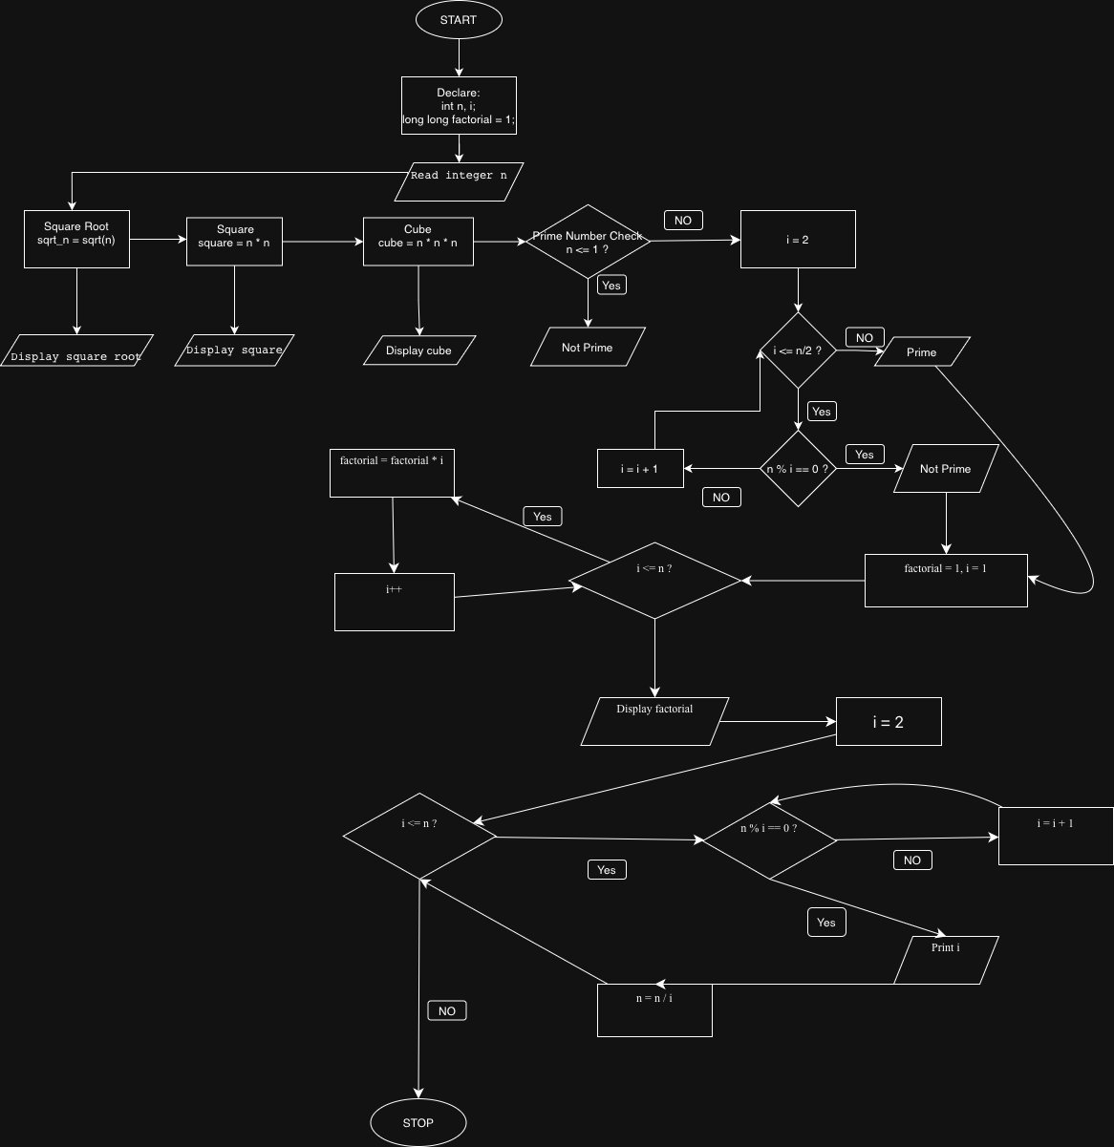

INPUT:
The user enters an integer number and selects an operation from the menu.
Example Input: Number: 5
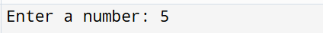

OUTPUT:
Example Output:
The program displays the result based on the selected operation.
Example Output: Cube = 125
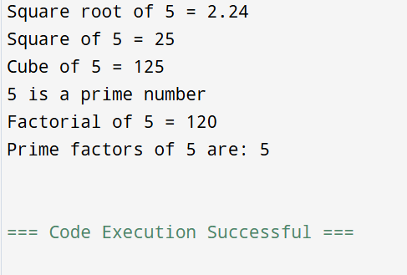

CONCLUSION:
Thus, the program to perform various mathematical operations on a number was successfully implemented using C programming. This program demonstrates the use of loops, conditional statements, switch-case, and mathematical functions.

